

**Hiring rooms at**

**Reading Quaker Meeting House**

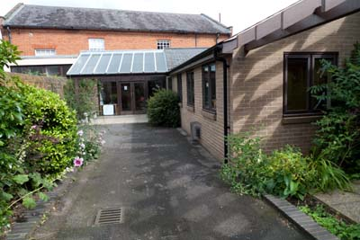

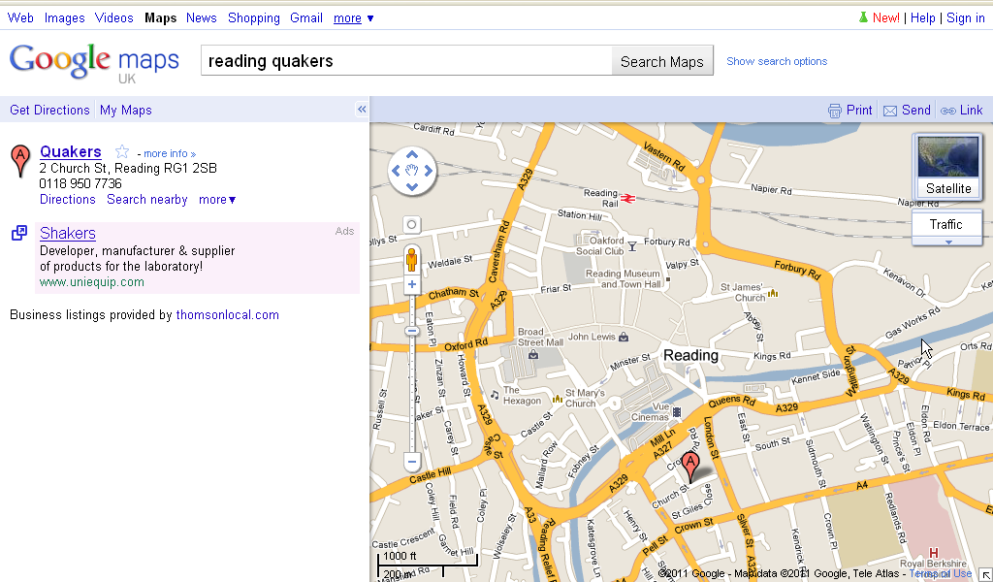

Address:

2 Church Street,

Reading

RG1 2SB

Email:

[hirings@readingquakers.org.uk](mailto:hirings@readingquakers.org.uk)

**Reading Quaker Meeting House:**

**Rooms and Equipment for Hire**

|  |  |  |
| --- | --- | --- |
| **Main Meeting Room**  **(ROOM 1)** | A spacious, light and peaceful room built in 1835. It has 100 chairs plus benches to seat an additional 80 (maximum capacity 180). *No food or drink allowed in this room.* | £19.50  per hour |
| **Hall**  **(ROOM 2)** | Ideal for seminars or presentations. Comfortably accommodates up to 50 people. 50 chairs available and eight large folding tables. Serving hatch to the kitchen. | £15.00  per hour |
| **Small Meeting Room**  **(ROOM 3)** | Perfect for discussion groups. Seats 15 around central or individual tables. Small adjacent kitchen suitable for tea making. | £11.50  per hour |
| **Committee Room**  **(ROOM 5)** | An intimate room with central or individual tables. Seats up to 10 people. | £9.00  per hour |
| **Children’s Room**  **(ROOM 4)** | A spacious and light room, ideal for adults or groups of up to 15 children aged 0-7, toys available. Small adjacent kitchen suitable for tea making. | £7.00  per hour |
| **Large kitchen** | Fully equipped with cooker, hot water urn, fridge, 80+ mugs, plates glasses, cutlery and double sink, serving hatch to Hall. **Please note that you may have to share the kitchen with other hirers. Cooker/kitchen not suitable for extensive hot food preparation.** | £10.00  per day |
| **Data Projector** | If you hire the data projector, you need to bring your own laptop. | £10  per day |

**Notes**

* Rooms are available for hire on Mondays from 8:30 to 13:00, and Tuesdays to Saturdays from 8:30 to 22:00. Rooms are not normally available on Sundays or bank holidays.
* There is no parking within the Meeting House grounds. Temporary access can be arranged for loading and unloading, or for a disabled driver.
* The building is accessible. It is all on one level with ramps to entrances. There is an accessible toilet.
* Baby changing facilities are available in the accessible toilet.
* The Main Meeting Room has a Hearing Aid Loop, which can be used on request.
* Flip chart stands, a large projector screen, display boards and extension lead are available free of charge. Pens and paper are not provided.
* Hirers should please make full use of our recycling system.

**Reading Quaker Meeting:**

**Hirings policy**

**Why do we hire rooms at our Meeting House?**

Hiring our rooms gives Quakers an opportunity for service in the world and offers users information about our values and practices.

We offer spaces for local groups, community organisations and others, whether faith-based or secular, without discrimination, provided that they respect Quaker values and do not disturb other hirers or those living or working in neighbouring premises.

Room hire charges are affordable and designed to cover the costs of running our buildings and to contribute to Quaker work.

**Who can hire rooms?**

Applications are reviewed to ensure that they are compatible with Quaker principles, such as truth, peace, social justice and respect for others. No public party-political meetings, however multi-party forums would be considered.

Founded on a basis of mutual trust, our detailed hiring arrangements are explained in the attached Terms and Conditions, which must always be respected.

**Reading Quaker Meeting House:**

**Terms and conditions of hiring**

**FIRE AND SAFETY**

1. Hirers must carry out their own risk assessment of the premises regarding their proposed usage.
2. Hirers should familiarise themselves with procedure in the event of fire. This is summarised in the Fire Action Plan (copies of which are fixed to the walls at various points in the Meeting House). They should also note the location of fire extinguishers and fire alarm points.
3. Hirers are responsible for informing their groups of the location of fire exits, the fire assembly point, and for recording those present so as to ensure that all have left the building in the event of fire.
4. Fire extinguishers are provided and maintained but must only to be used by persons who have completed appropriate training. If anybody else uses them, it is on the understanding that they accept full responsibility for any damage or injury which may result.
5. Naked flames (e.g. candles) are not permitted.
6. Fire exit doors must not be blocked or wedged open at any time.

**SAFEGUARDING, SECURITY AND OTHER USERS**

1. Hirers should remember that the Meeting House is open to the public. Do not remain in the building alone or leave items unattended. If you believe that there is an intruder in the building who could present a risk, please call the police immediately and then inform the warden.
2. Hirers and all members of their group must respect other users of the building and avoid harmful acts and situations arising that might affect other users.
3. Hirers are requested to be mindful of the safeguarding of children and vulnerable adults who are members of other groups.
4. Hirers who anticipate safeguarding issues must discuss these in advance of their visit. All efforts will be made to accommodate safeguarding requirements when given notice.
5. The Hirer must undertake to take reasonable precautions to ensure that any children and vulnerable people at their event are kept safe and are covered by the hirer’s own safeguarding policy.
6. Mid Thames Area Meeting has its own safeguarding policy which can be provided upon request.

**LEAVING THE MEETING HOUSE**

1. When you leave, furniture should be returned to its original position and any food or drink spills cleared. If you produce more than one bin-bag of rubbish, please take it with you.
2. As you leave, check that all windows are closed, lights and heating are turned off (please check the toilets) and doors are securely closed.
3. Please note that failure to leave the premises at the agreed time will result in additional charges being levied. Failure to leave the premises in acceptable order may also result in additional charges, e.g. for cleaning or damage to furnishing.

**ALCOHOL AND SMOKING**

1. Alcohol is prohibited in all areas of the premises, including the garden.
2. Smoking and/or vaping is prohibited indoors. Smoking and/or vaping outside is allowed. If ashtrays are provided, please use them, otherwise dispose of cigarette ends responsibly. Illegal substances must not be bought into or used in meeting rooms or spaces.

**NOISE**

Noise must be kept to a respectful level in order not to disrupt groups in other rooms, or our neighbours, both when using the premises and upon leaving.

**LICENSING**

The Meeting House is not licensed for public entertainment, so no charges may be made at the door to members of the public. It may be possible for a hirer to obtain a temporary event notification for a paying event, but please discuss this in advance.

**EMERGENCIES**

We reserve the right to halt or terminate the hiring at any stage in an emergency. Our liability to the hirer will be limited to a full refund of any payment made by the Hirer in respect of the hiring.

**AUDIO AND ELECTRICAL EQUIPMENT**

Notification must be given in advance if you want to use your own electrical or audio/video equipment. Mains-powered portable electrical items (including laptops and phone chargers) that have been certified to be safe (as indicated by a current PAT inspection label) may be used on the premises.

There is no TV Licence for the premises.

**ANIMALS**

No animals, apart from guide or assistance dogs, shall be brought into the premises, including the garden.

**INSURANCE**

Our insurance covers public liability for Quaker events, and employer’s liability (including our own volunteers) as well as buildings and contents. Our insurance policy does not cover personal effects or the Hirer’s public liability and the Hirer must ensurethat they take out their own insurance to cover both personal effects and public liability.

**INDEMNITY**

The Hirer shall indemnify the Quaker Meeting against any claim, action or proceedings resulting from use of the hall by the hirer and pay any costs incurred.

**LOSS, DAMAGE or INJURY**

1. The Quaker Meeting accepts no liability for injury, damage or loss not directly attributable to negligence of their employees or agents.
2. The hirer shall be liable for all loss or damage to the premises, furniture, or fittings occurring during the period of hire. Any damage and breakages must be reported immediately and will be charged for at the replacement cost.

**ADVERTISING**

1. Any advertising must not imply that your event is organised or supported by the Religious Society of Friends (Quakers) unless this has been specifically agreed. The contact details of the event organiser must appear on any publicity materials.
2. Hirers must have permission from Reading Quaker Meeting Clerks to leave any leaflets or printed materials anywhere in the Meeting House.

**BOOKING, CANCELLATION AND PAYMENT**

**Booking**

1. A booking form must be completed for each event, or series of repeat events, and include adequate time to set up before your event, and clear away afterwards. This can be a physical form or an exchange of emails agreeing to these terms and conditions.
2. The person signing the booking form is liable for the cost of the hiring. If the person is signing on behalf of an organisation, then the individual and organisation are jointly liable.
3. When a signed booking form has been received, your booking will be confirmed in writing, your booking is not made until you have received this confirmation.

**Cancellation**

If you cancel a session(s) giving greater than 7 days’ notice, no charge will be made. We reserve the right to charge the following for late bookings or failure to give notice of cancellation. Less than 7 days’ but more than 48 hours’ notice, a charge of 50% of the total will be made. If you give less than 48 hours’ notice, or fail to give notice, you will be charged the full amount.

**Payment**

Invoices are normally sent out monthly in arrears, by email, with payment due within 21 days of the invoice date by bank transfer. Cheques are acceptable if other payment means are not possible.

**HIRING RATES AND DISCOUNTS**

1. The minimum period chargeable for any hire is 2 hours.
2. There’s a 10% discount on the hourly rates for booking 10 or more sessions at one time.
3. If the entire building is required for an all-day event (6 hours or more) we offer a 25% discount on the hourly rates. This is subject to paying a 25% deposit at the time of booking.
4. We may exceptionally agree reduced or free hirings for specific organisations whose work is in line with Quaker values or reflects a discerned concern of Reading Quakers. (This wording is taken form the new AM policy, ‘Charges,’ point 5.)
5. Hiring charges are reviewed annually, any increase normally commencing from January 1st.

**Reading Quaker Meeting House:**

**Booking form**

**Information about hirer**

|  |  |
| --- | --- |
| Organisation name and postal address |  |
| Description of Organisation’s Activities |  |
| Your Name |  |
| Contact Phone Number(s) |  |
| Email Address |  |
| Session title and activity planned (e.g. ‘Yoga class’) |  |

**Booking Request**

|  |  |  |
| --- | --- | --- |
| Date(s) |  | |
| Times  **Please include time needed to set up and tidy away** | From: | To: |
| Room(s) |  | |
| How many people are expecting to attend, including the facilitators? |  | |
| How did you hear about us? |  | |
| Kitchen use? (delete as applicable) | Yes / No What will you be using the kitchen for? | |
| Data projector? (delete as applicable) | Yes / No | |

**Payment details**

|  |  |
| --- | --- |
| Preferred method of payment?  (delete as applicable) | Bank transfer (preferred) / Cheque |
| Email address for invoicing. |  |
| Your reference number/code, if applicable. |  |

**Agreement**

**By signing this booking form, I agree that I have read and agree to the Terms and Conditions of hire laid out above in the Hirings Policy, and understand that failure to abide by them may cause the cancellation of future bookings, or prevent me from the further hiring of rooms at Reading Quaker Meeting House.**

**If this form is sent via email, it will be considered to have been signed by the person named here.**

|  |  |
| --- | --- |
| Signed (typed is acceptable) |  |
| Print Name |  |
| Date sent |  |

Please send to:

[hirings@readingquakers.org.uk](mailto:hirings@readingquakers.org.uk) (preferred)

Or

6 Church Street,

Reading RG1 2SB